
Unit 1
Semester 1 2019
ATAR Chemistry Test 1
Atomic Structure, Moles & Periodic Table Test

Name ____________________________

Total time allowed: 55 minutes. Total marks: 65 marks

Materials allowed for this section:
SCSA Chemistry Data Sheet (provided)
SCSA Approved Scientific Calculators

Part 1 – Multiple Choice

Answer ALL questions in part 1 on the Multiple Choice part of the Answer Sheet provided. Indicate the correct answer with a cross (X). This part carries 24 marks – 1 mark for each question.

- An atomic species contains 11 protons and 13 neutrons in its nucleus, surrounded by 10 electrons. The symbol for this species would be:

- Ne
- Na
- Na⁺
- Mg²⁺

- The element with atomic number equal to 11 is likely to have similar chemical properties to the element with atomic number equal to
- 2
- 3
- 4
- 5

3. Which of the following trends, as you go across period 3 from Na to Ar, is NOT correct?
- Electronegativity increases.
- Atomic radii increases.
- Atomic Mass increases.
- First ionisation energy increases.

4. Which one of the following is true of the atoms of a given neutral element?

- The number of neutrons must be greater than the number of electrons
- The number of protons must be equal to the number of neutrons
- The number of protons must be equal to the number of electrons
- The number of protons must be greater than the number of neutrons

5. How many protons and electrons are present in a Ca²⁺ ion?

- 18 protons and 20 electrons
- 20 protons and 18 electrons
- 20 protons and 22 electrons
- 22 protons and 20 electrons

6. Which of the following elements has the highest first ionization energy?

- O
- P
- Al
- Mg

7. The relative atomic mass of magnesium is 24.3. Assuming it has two isotopes, which of the following statements is true?

- Both isotopes are equally abundant in nature
- The isotope of mass 24 is more abundant
- The isotope of mass 25 is more abundant
- Both the isotopes have the same atomic mass of 24.

8. Which one of the elements below is the most electronegative?

- O
- C
- Mg
- Se

9. Which value is closest to the number of feathers there are in 2 moles of feathers?

- 6.0 × 10²³
- 1.2 × 10²⁴
- Need to know average mass of feathers
- 3 × 10²³

The next question refers to the graph below showing the (first) ionisation energies of the first 20 elements.

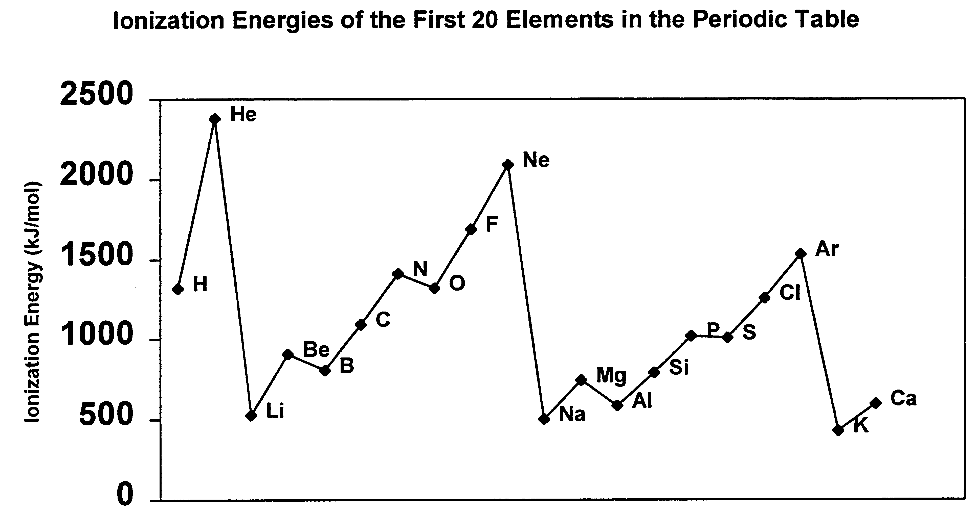

10. Which one of the following best accounts for the general increase in ionisation energy across a row of the periodic table?

  - The decreasing distance between the nucleus and the outer electrons in the atoms of the elements across a row
  - The increasing nuclear charge within the atoms of the elements across a row
  - The increasing number of electrons in the atoms of the elements across a row
  - The increasing number of neutrons in the atoms of the elements across a row

11. Which of the following statements regarding atomic particles is FALSE?

  - Protons are found in the nucleus and are positively charged particles.
  - Electrons move around the nucleus and contribute little to the mass of the atom.
  - Neutrons are found in the nucleus and they have no charge.
  - The numbers of neutrons, protons and electrons are always equal in a neutral atom.

12. 1 mole of chlorine gas (Cl₂) and 1 mole of lithium chloride (LiCl) are weighed. The total mass is:

  - 77.87 g
  - 113.3 g
  - 106.35 g
  - 1.2 × 10²⁴ particles

13. The molar mass (M) of the gas butane (C₄H₁₀), found in cigarette lighters is:

- 58.12 g/mol
- 58 g mol⁻¹
- 34 g mol⁻¹
- 26.12 g/mol

14. Which subatomic particle contributes mass but no charge to the atom?
- Proton
- Neutron
- Electron
- Nucleus

15. The atomic number of zinc is:
- 65.
- 30.
- 91.
- 40.

For questions 16–18 refer to the table below, which shows the electron configuration of six atoms,
labelled I–VI.

Atom | I | II | III | IV | V | VI
Electron configuration | 2, 1 | 2, 8, 7 | 2, 8, 8, 2 | 2, 8 | 2, 3 | 2, 8, 1

16 Which atom/s are from the same period of the periodic table?
- I, II
- I, VI
- II, III, VI
- I, IV, V

17 Which atom is an inert(Noble) gas?
- I
- II
- III
- IV

18 Which atom has five protons?
- I
- III
- V
- VI
19 Why is the relative atomic mass on the periodic table a decimal?
A It is the average of the abundance and mass of all of the isotopes of the element.
B It is the average of the abundance and mass of all of the allotropes of the element.
C It depends on the percentage abundance of the element in the Earth’s crust.
D It depends on which atom of carbon the element is being compared to.

20 Which of the elements below has the largest atomic radius?
A Potassium
B Calcium
C Bromine
D Krypton

21 Which of these elements has the lowest ionisation energy?
A Fluorine
B Chlorine
C Bromine
D Iodine

22 Which of these elements has the lowest electronegativity?
A Fluorine
B Chlorine
C Bromine
D Iodine

23 Which of the following elements will react with water in similar ways?
A Na and Al
B Na and K
C Mg and P
D Li and Br

24 An element has the following ionization energies:

First | Second | Third | Fourth | Fifth
0.80 | 2.43 | 3.66 | 25.02 | 32.82

The most likely identity of this element is:

A Lithium
B Magnesium
C Boron
D Carbon

End of Part A

Part 2 – Short Answer Questions

- The terms uranium-235 and uranium-238 are often heard in discussions about nuclear power and nuclear weapons.
- State one feature that is the same for an atom of uranium-235 and an atom of uranium-238.

- State one feature that makes atoms of uranium-235 and uranium-238 different.

(2 marks)

- What is the Molar Mass of:
- Magnesium ? (1 mark)

- Calcium Carbonate (CaCO₃) ? Show all working for full marks (3 marks)

- In the space below, draw a diagram to represent an atom of Aluminium. Make sure you show the numbers of subatomic particles in the nucleus as well as the electron configuration. (3 marks)

- Draw electron shell diagram to represent the electron configuration of an atom of Sulfur. (2 marks)

For the following Questions 5 and 6 - be sure to show all working for full marks.

- How many moles of:

- Hydrogen atoms are there in 5.0 moles of H₂SO₄ ? (1 mark)

- Sodium is there in 64.2 g of Sodium metal? (2 marks)

- Carbon are in 200g of CaCO₃ ? (3 marks)

- Determine the percentage composition of hydrated copper sulfate, CuSO₄.5H₂O. (5 marks)

- Define the following terms. (4 marks)

- ionisation energy

- electronegativity

- isotope

- ion

- Complete the following table. (3 marks)

Element  (neutral atoms) | Atomic number | Mass number | Number of protons | Number of neutrons | Number of electrons
⁹Be

Selenium |  |  |  | 45
 |  |  |  | 10 | 9

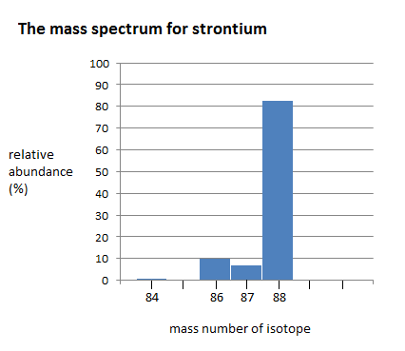
- The diagram below shows the mass spectrum for strontium.

a. How many isotopes does strontium have? __________ (1 mark)

b. Which isotope is most abundant? __________ (1 mark)

c. Calculate the relative atomic mass of strontium. (3 marks)

- Describe the trend in atomic radius across a period (from left to right). (1 marks)

- Explain the trend that atomic radius shows across the periodic table(from left to right)
(3 marks)

12. The first four successive ionization energies for the element Beryllium are shown in the graph below:
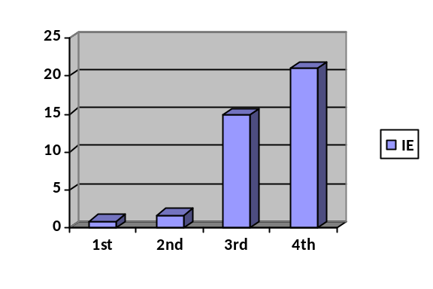
  - Explain why the ionization energy increases as each successive electron is removed from the beryllium atom. (1 mark)

  - Explain the dramatic increase in the third ionization energy of Berylium. (1 mark)

END OF TEST
Name…………………………………………

TEST 1 – ATOMIC STRUCTURE, MOLES AND THE PERIODIC TABLE

Section 1 – Multiple Choice Questions (24 marks in total)

Mark your selected answer with a ‘X’

1. | A | B | C | D |  | 13. | A | B | C | D
2. | A | B | C | D |  | 14. | A | B | C | D
3. | A | B | C | D |  | 15. | A | B | C | D
4. | A | B | C | D |  | 16. | A | B | C | D
5. | A | B | C | D |  | 17. | A | B | C | D
6. | A | B | C | D |  | 18. | A | B | C | D
7. | A | B | C | D |  | 19. | A | B | C | D
8. | A | B | C | D |  | 20. | A | B | C | D
9. | A | B | C | D |  | 21. | A | B | C | D
10. | A | B | C | D |  | 22. | A | B | C | D
11. | A | B | C | D |  | 23. | A | B | C | D
12. | A | B | C | D |  | 24. | A | B | C | D

